Easter Prayer Tree

This week starting on Palm Sunday is the start of the Holy Week. During this week you may like to spend time as a family coming close to God as you journey the steps that Jesus took. One way you may like to do this is by making an Easter prayer tree together. The first task would be to find some good branches and put them in a sturdy vase on a table Then each day share a small Bible reading and respond by doing the creative prayer, that would then be hung on the tree that day. Print and cut out the number of symbols you need for each member of the family, in preparation for each day. You can punch a hole into each symbol and have some string, wool or cotton thread ready to thread through the holes to tie the symbols to the branches at the end of each activity.

Palm Sunday – Mark 11:1-11
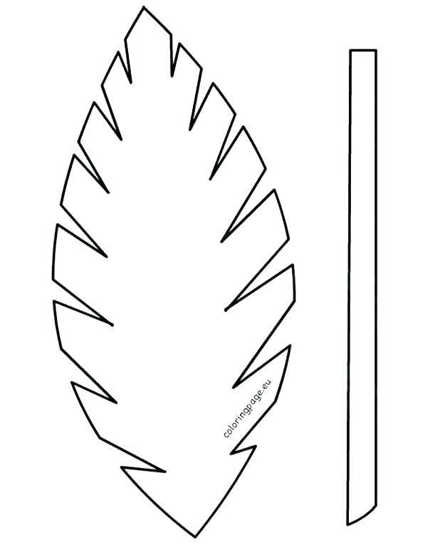
Palm Sunday is the day when we remember Jesus riding into Jerusalem on a donkey. The crowd picked up palm branches and waved them in praise to Jesus. The branches were a symbol of victory and celebration. Talk together as you chat through these questions.
Would you have joined in with the crowd?
How would you have felt if you had been there?
How do we recognise Jesus in the world today?
On the palm leaf symbol draw or write your praise to Jesus.
Hang your leaves on your Easter Prayer tree.

Monday – Mark 11:15-19
When Jesus came to the temple during the yearly Passover celebrations he was outraged that temple leaders were letting merchants do their business in the parts of the temple that were supposed to be used for special worship to God. They were more worried about money from selling animals to sacrifice than about worshiping God. The money changers were distracting people from worshipping God.
As a family talk about what distracts you from reading your Bible,
praying and coming close to God.
What could you do to help each other not be distracted?
On the coin symbol draw or write on the back the things that
distract you from God and ask Him to help you to stay focused on him.
Hang your coins on your Easter Prayer tree

Tuesday - Mark 14:1-11
The woman in today’s story showed her great love for Jesus. After you have read the story, talk together about the ways we can show our love to Jesus. How can we show Jesus’ love to other people? Do we know how much Jesus loves us?
Sit for a moment quietly with Jesus, what is Jesus saying to you?
What words of love might you want to say to Jesus.
Draw or write the words that you say to each other on the heart shape.
Hang your heart symbol on the Easter Tree

Wednesday – John 13:1-17
Jesus is said to be a Servant King, he came to serve not to be served. In todays reading Jesus washed his friends feet just like a servant would do. He was trying to show his followers that they all need to serve each other.
Maybe you could take turns in washing each other’s feet?
Do you feel different when your feet are being washed
or when you are washing others feet?
Talk together about the ways that you can serve
and help each other at home during this time.
How can you as a family serve your neighbours and community?
Draw or Write on the foot symbol, the things that you would like to do to help and serve your family and your community. Ask God to help you to be a loving servant to others.
Hang the foot symbol on the Easter Tree as you pray.

Maundy Thursday – Mark 14:12-26
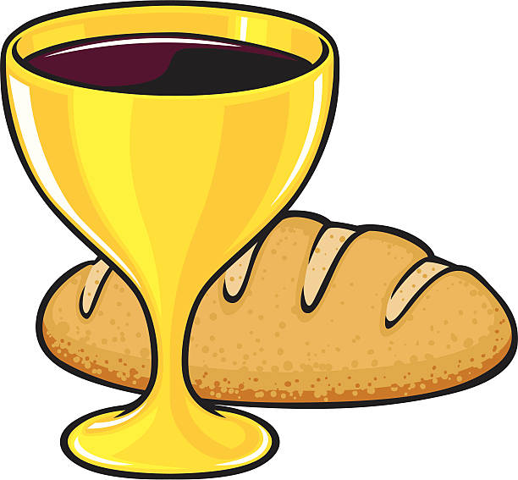
Maundy Thursday is the day before Good Friday. On this day, we remember the last Supper that Jesus shared with his disciples. ‘Maundy’ comes from Latin word which means a command, and it refers to Jesus’ command that he gave at the Last Supper, that we must love one another as he loves us.
As a family eat some bread and drink some red juice
or grape juice and talk about the Last supper.
Why is it called The Last Supper?
Why did Jesus ask us to remember him in this way?
Why is it such a special meal?
How can we include Jesus in our special occasions and into our everyday ordinary lives?
Draw or write a thank you prayer to Jesus for dying for us on the Wine glass and bread symbol.
Hang this symbol on the Easter Tree.

Good Friday – Mark 15:1-39
This is a sad time of remembering Jesus suffering and dying on the cross but it is a good time to remember that Jesus was willing to die for us. When Jesus died on the cross he took all our sins with him.
As we remember Jesus on the cross it is a time to be quiet and say sorry for the things we do that are not what God wants us to think, say and do.
You can make a cross out of sticks and hang them on your
Easter Tree as you say a sorry prayer or use the cross symbol
to draw or write a sorry prayer or just the word sorry.
Hang the cross with your sorry prayer on your Easter Tree.

Holy Saturday – Mark 15:40-47
As we wait between Good Friday and the celebration of Easter day talk together about how the disciples would have been feeling.
They did not know about what was to happen on Easter Day.
How do we feel when we are waiting?
Jesus was about to change the disciples’ life completely.
How would you like Jesus to change your life?
We are all in a time of uncertainty not sure what will happen next. But we can be certain that God will be with us and we can be certain to trust that he will guide us through.
On the clock symbol draw or write how you are feeling in this uncertain time.
You may even just want to write ‘I trust you God’ and turn it into a prayer as you hang the clock on your Easter Tree.

Easter Sunday – Mark 16:1-20
Jesus has Risen!! Death could not hold Him! Jesus is Alive! This is a great day to celebrate. It is the day we can go on an Easter egg hunt and eat our chocolate eggs too!! The egg is a symbol of new life and we can now boast that we have a new life too.
God has forgiven us through Jesus. We can start a new life with God.
We can call him our Father and thank and praise him that
we are forgiven and loved! If you have any egg tree decorations
you can add them to your prayer tree or draw or write on the
egg symbol saying a thank you prayer to God for all that
Jesus has done for us.

You may want to take a picture of your Easter tree and post it on our 3CC Facebook page for others to see.

