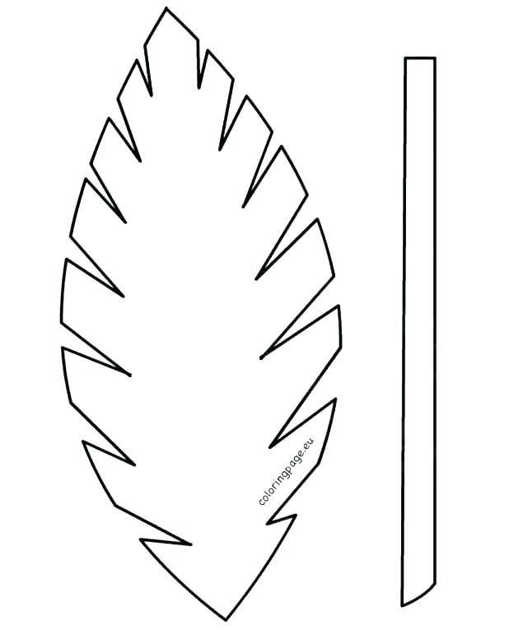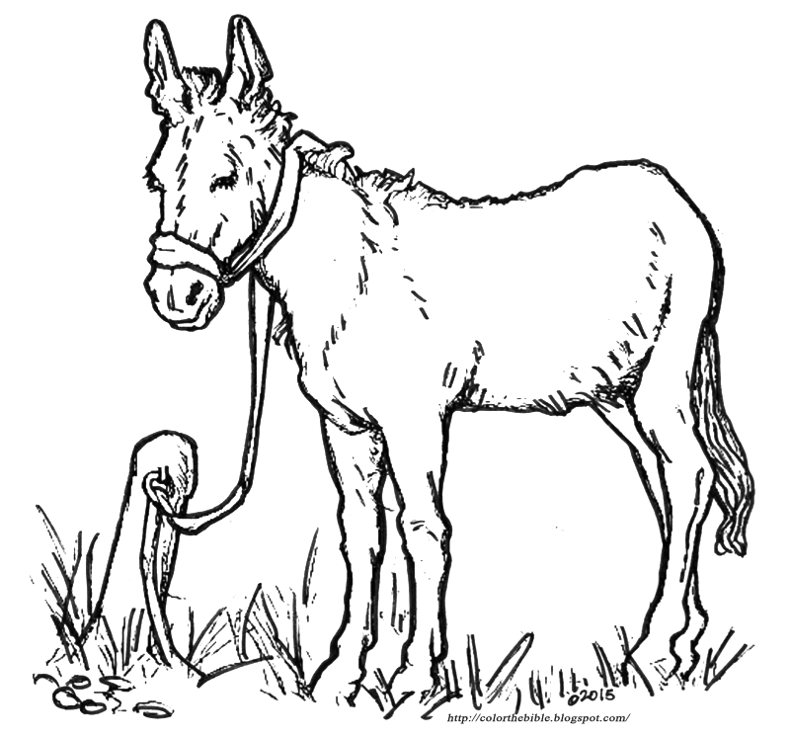

How do you see yourself? Write down how you would describe yourself.

What are the things you like about yourself?

What are the things that you don’t like about yourself?

How do you see Jesus?

Write down on the palm leaf the words that describe Jesus.

How will you carry Jesus in your thoughts, words and actions today?

Spend some time in Jesus’ presence listening to Him.

What is Jesus saying to you today? Write or draw it.

Do you believe the words he is saying to you?

**Palm Sunday**

Be Carriers of Jesus